error function

Def

$$erf\left(z\right)$$

= $$\frac{2}{{\left(pi\left(\right)\right)}^{\frac{1}{2}}}⋅integral\left(e^{−t^{2}},t=0,t=\inf{}\right)$$

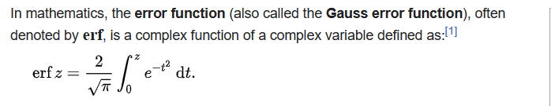

PDF

$$f\left(x\right)$$

= $$\left(\frac{c}{pi{\left(\right)}^{\frac{1}{2}}}\right)⋅e^{−cx^{2}}$$

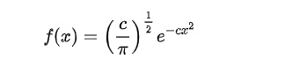

Probability of error

Glaisher calculates the probability of an error lying between $$p$$ and $$q$$:

$$\frac{c}{pi\left(\right)}⋅integral\left(e^{−cx^{2}},x=p,x=q\right)$$

Application

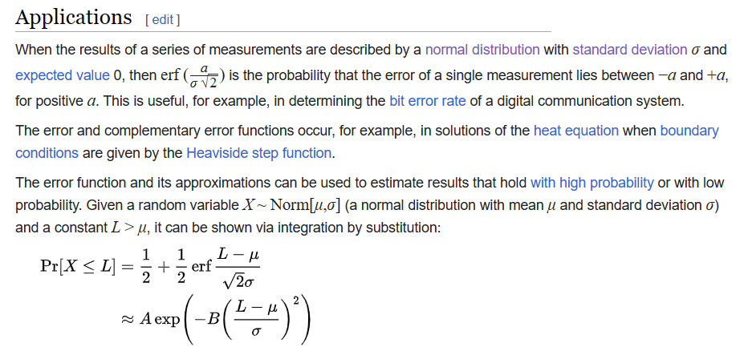

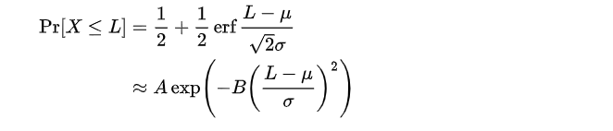

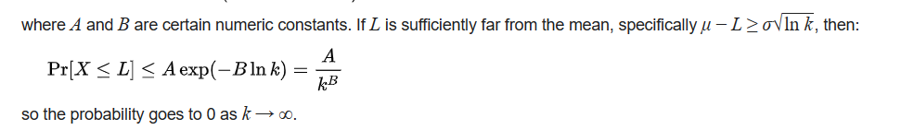

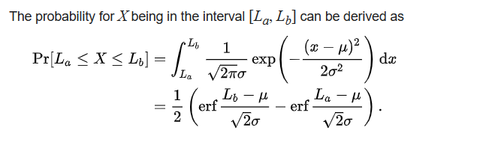

Property

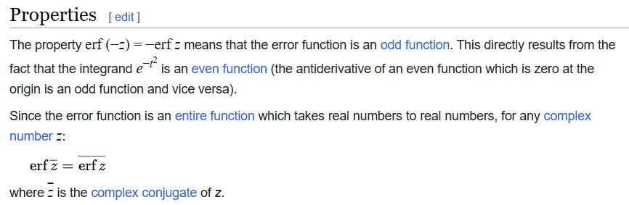

$$erf\left(conj\left(z\right)\right)$$

= $$conj\left(erf\left(z\right)\right)$$

$$erf\left(z\right)$$

= $$\frac{2}{pi{\left(\right)}^{\frac{1}{2}}}⋅sigma\left(\frac{{\left(−1\right)}^{n}z^{2n+1}}{n!\left(2n+1\right)}\right)$$

= $$\frac{2}{pi{\left(\right)}^{\frac{1}{2}}}⋅sigma\left(z⋅product\left(−\frac{\left(2k−1\right)z^{2}}{k\left(2k+1\right)},k=1,k=n\right)\right)$$

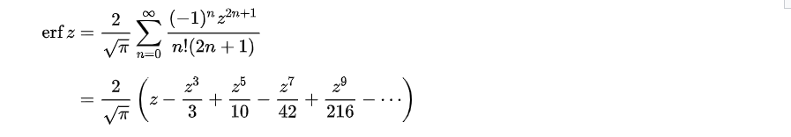

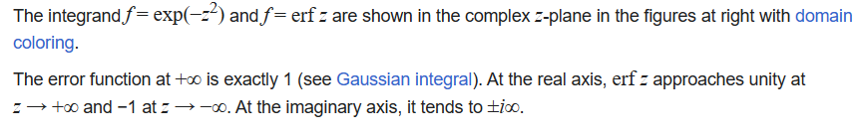

$$\frac{d}{dz}erf\left(z\right)$$

= $$\frac{2}{pi{\left(\right)}^{\frac{1}{2}}}⋅e^{−z^{2}}$$

$$erf^{−1}\left(z\right)$$

= $$z⋅erf\left(z\right)+\frac{e^{−z^{2}}}{pi{\left(\right)}^{\frac{1}{2}}}$$

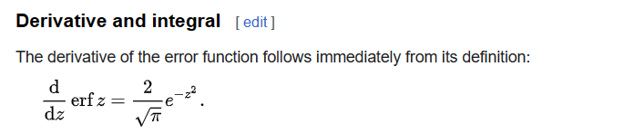

$$erf^{\left(k\right)}\left(z\right)$$

= $$\frac{2{\left(−1\right)}^{k−1}}{pi{\left(\right)}^{\frac{1}{2}}}H_{k−1}\left(z\right)⋅e^{−z^{2}}$$

= $$\frac{2}{pi{\left(\right)}^{\frac{1}{2}}}⋅\frac{d^{k}}{dz^{k−1}}\left(e^{−z^{2}}\right)$$, for all $$k$$ = $$1,2,…$$

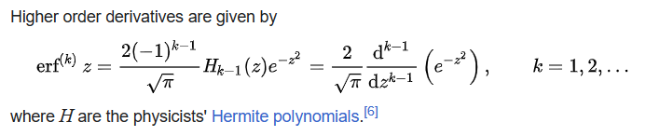

Factorial series

$$erf\left(z\right)$$

= $$\frac{2}{pi{\left(\right)}^{\frac{1}{2}}}⋅sigma\left(\frac{{\left(−2\right)}^{n}⋅\left(2n−1\right)‼}{\left(2n+1\right)!}⋅z^{2n+1},n=0,n=\inf{}\right)$$

Integral of error function with Gaussain density function

$$integral\left(erf\left(ax+b\right)⋅\frac{1}{{\left(2⋅pi\left(\right)\right)}^{\frac{1}{2}}⋅std\left(X\right)}⋅e^{−\frac{z^{2}}{2}}dx,x=−inf,x=\inf{}\right)$$

= $$erf\left(\frac{a⋅E\left[X\right]+b}{{\left(1+2a^{2}std{\left(X\right)}^{2}\right)}^{\frac{1}{2}}}\right)$$

for all $$a,b,E\left[X\right],std\left(X\right)$$ belongs to real number.

Ref

[Error function - Wikipedia](https://en.wikipedia.org/wiki/Error_function)